**Mini project for student grading system using java concepts**

**AIM :**

**To develop a mini project for student grading system using java concepts**

**PROCEDURE :**

**1.Start the program.**

**2.Include all necessary header file.**

**3.Create a class studentgrade with extends application.**

**4.Create a scene set menu bar that contains about, edit, help, database and give action for the menu bar. and in same scene create a button next to navigate next page.**

**5.create a scene and create label, text field for registration number and password.**

**6.Create a button to navigate next page.**

**7.create a scene and set label user id , department , year and create text field for it and get the inputs from user and create another button to navigate next page.**

**8.Set alert conditions for both the buttons.**

**9.Create scene and set a label name , phone number ,mail id ,Date of birth and get inputs from user and create a button to navigation.**

**10.Create a scene and set Name , Maths, Science, English label and create buttons calculate grade ,go to search, quiz.**

**10.If we click calculate grade, the button will display name ,total, average, grade.**

**11.If we click button quiz it will show questions we can select answer through checkbox and the page have button called submit to submit answer and it has a button known as previous to navigate previous page.**

**12.If we click button go to search a text field will get users name and the page has a button called**

**Search to display students details and while clicking the button exit it will terminate from current page.**

**13.Stop the program.**

**PROGRAM:**

**package application;**

**import javafx.application.Application;**

**import javafx.geometry.HPos;**

**import javafx.geometry.Insets;**

**import javafx.geometry.Pos;**

**import javafx.geometry.VPos;**

**import javafx.scene.Group;**

**import javafx.scene.Scene;**

**import javafx.scene.control.Alert;**

**import javafx.scene.control.Button;**

**import javafx.scene.control.CheckBox;**

**import javafx.scene.control.Label;**

**import javafx.scene.control.Menu;**

**import javafx.scene.control.MenuBar;**

**import javafx.scene.control.MenuItem;**

**import javafx.scene.control.Separator;**

**import javafx.scene.control.TextField;**

**import javafx.scene.effect.Blend;**

**import javafx.scene.effect.BlendMode;**

**import javafx.scene.effect.DropShadow;**

**import javafx.scene.effect.InnerShadow;**

**import javafx.scene.image.Image;**

**import javafx.scene.layout.Background;**

**import javafx.scene.layout.BackgroundFill;**

**import javafx.scene.layout.BackgroundImage;**

**import javafx.scene.layout.BackgroundPosition;**

**import javafx.scene.layout.BackgroundRepeat;**

**import javafx.scene.layout.BackgroundSize;**

**import javafx.scene.layout.BorderPane;**

**import javafx.scene.layout.ColumnConstraints;**

**import javafx.scene.layout.CornerRadii;**

**import javafx.scene.layout.GridPane;**

**import javafx.scene.layout.Region;**

**import javafx.scene.layout.StackPane;**

**import javafx.scene.paint.Color;**

**import javafx.scene.text.Font;**

**import javafx.scene.text.FontPosture;**

**import javafx.scene.text.FontWeight;**

**import javafx.scene.text.Text;**

**import javafx.scene.text.TextAlignment;**

**import javafx.scene.web.WebEngine;**

**import javafx.scene.web.WebView;**

**import javafx.stage.Stage;**

**public class menu extends Application {**

**private Region grid;**

**private Stage primaryStage;**

**private Scene scene1,sct1,scene,sc,sce,scc3,scene9,scene99,scene44;**

**@Override**

**public void start(Stage primaryStage)throws Exception {**

**this.primaryStage=primaryStage;**

**// Create a menu bar**

**MenuBar menuBar = new MenuBar();**

**Menu fileMenu = new Menu("About");**

**Menu editMenu = new Menu("Edit");**

**Menu helpMenu = new Menu("Help");**

**// Create menu items**

**MenuItem newMenuItem = new MenuItem("Exam timetable");**

**MenuItem openMenuItem = new MenuItem("FEES DUE");**

**MenuItem saveMenuItem = new MenuItem("SCHOLARSHIP");**

**MenuItem cutMenuItem = new MenuItem("Previous year question paper");**

**MenuItem copyMenuItem = new MenuItem("Bus details");**

**MenuItem pasteMenuItem = new MenuItem("Paste");**

**MenuItem aboutMenuItem = new MenuItem("Datbase");**

**// Add menu items to menus**

**fileMenu.getItems().addAll(newMenuItem, openMenuItem, saveMenuItem);**

**editMenu.getItems().addAll(cutMenuItem, copyMenuItem, pasteMenuItem);**

**helpMenu.getItems().addAll(aboutMenuItem);**

**// Add menus to the menu bar**

**menuBar.getMenus().addAll(fileMenu, editMenu, helpMenu);**

**Button go= new Button("next");**

**go.setOnAction(e->goTogo());**

**// Create a grid pane**

**GridPane gridPane1 = new GridPane();**

**gridPane1.setHgap(10);**

**gridPane1.setVgap(10);**

**gridPane1.setPadding(new Insets(25, 25, 25, 25));**

**String initialImagePath = "file:/D:/joffin/grade2.png";**

**Image initialBackgroundImage = new Image(initialImagePath);**

**BackgroundSize backgroundSize1 = new BackgroundSize(800,800, false, false, false, false);**

**BackgroundImage initialBgImg = new BackgroundImage(**

**initialBackgroundImage,**

**BackgroundRepeat.NO_REPEAT,**

**BackgroundRepeat.NO_REPEAT,**

**BackgroundPosition.DEFAULT,**

**backgroundSize1**

**);**

**Background initialBackground = new Background(initialBgImg);**

**gridPane1.setBackground(initialBackground);**

**newMenuItem.setOnAction(e -> {**

**String imagePath = "file:/D:\\joffin/exam.jpg";**

**Image backgroundImage = new Image(imagePath);**

**BackgroundSize backgroundSize = new BackgroundSize(800, 800, false, false, false, false);**

**BackgroundImage backgroundImg = new BackgroundImage(**

**backgroundImage,**

**BackgroundRepeat.NO_REPEAT,**

**BackgroundRepeat.NO_REPEAT,**

**BackgroundPosition.DEFAULT,**

**backgroundSize**

**);**

**Background background = new Background(backgroundImg);**

**});**

**openMenuItem.setOnAction(e -> {**

**String imagePath = "file:/D:\\joffin/due.png";**

**Image backgroundImage = new Image(imagePath);**

**BackgroundSize backgroundSize = new BackgroundSize(800, 800, false, false, false, false);**

**BackgroundImage backgroundImg = new BackgroundImage(**

**backgroundImage,**

**BackgroundRepeat.NO_REPEAT,**

**BackgroundRepeat.NO_REPEAT,**

**BackgroundPosition.DEFAULT,**

**backgroundSize**

**);**

**Background background = new Background(backgroundImg);**

**});**

**// Add the menu bar to the grid pane**

**gridPane1.add(menuBar, 1, 0);**

**gridPane1.add(go, 20,50 );**

**scene9=new Scene(gridPane1, 400, 300,Color.AQUA);**

**GridPane jo = new GridPane();**

**jo.setBackground(new Background(new BackgroundFill(Color.rgb(0, 0, 0), new CornerRadii(0), new Insets(0))));**

**jo.setAlignment(Pos.CENTER);**

**jo.setHgap(10);**

**jo.setVgap(10);**

**jo.setPadding(new Insets(25, 25, 25, 25));**

**scene1 = new Scene(jo, 300, 200);**

**String imagePath = "file:/D:\\joffin/book2.png";**

**Image backgroundImage = new Image(imagePath);**

**Label regno = new Label("REGISTRATION NUMBER");**

**regno.setStyle("-fx-font-weight: bold;");**

**regno.setTextFill(Color.web("white", 0.8));**

**Label pas = new Label("PASSWORD");**

**pas.setStyle("-fx-font-weight: bold;");**

**pas.setTextFill(Color.web("white", 0.8));**

**TextField s = new TextField();**

**s.setPromptText("enter REGISTRATION NUMBER");**

**TextField js = new TextField();**

**js.setPromptText("enter PASSWORD");**

**Button loginButton = new Button("LOGIN");**

**loginButton.setStyle("-fx-background-color: yellow;");**

**loginButton.setOnAction(e -> {**

**String REGISTRATIONNUMBER = s.getText();**

**String password = js.getText();**

**if (REGISTRATIONNUMBER.equals("9213221") && password.equals("password")) {**

**showAlert("Login Successful", "Welcome, " + REGISTRATIONNUMBER + "!");**

**// Proceed after successful login**

**goTologin();**

**} else {**

**showAlert("Login Failed", "Invalid username or password!");**

**}**

**});**

**jo.add(regno, 0, 0);**

**jo.add(s, 1, 0);**

**jo.add(pas, 0, 1);**

**jo.add(js, 1, 1);**

**jo.add(loginButton, 1, 4);**

**jo.setBackground(new javafx.scene.layout.Background(new javafx.scene.layout.BackgroundImage(**

**backgroundImage,**

**javafx.scene.layout.BackgroundRepeat.NO_REPEAT,**

**javafx.scene.layout.BackgroundRepeat.NO_REPEAT,**

**javafx.scene.layout.BackgroundPosition.DEFAULT,**

**new javafx.scene.layout.BackgroundSize(900, 1200, false, false, false, false)**

**)));**

**GridPane grid = new GridPane();**

**grid.setBackground(new Background(new BackgroundFill(Color.rgb(40, 239, 255), new CornerRadii(0), new Insets(0))));**

**grid.setAlignment(Pos.CENTER);**

**grid.setHgap(10);**

**grid.setVgap(10);**

**grid.setPadding(new Insets(25, 25, 25, 25));**

**String imagePath1 = "file:/D:\\joffin/mount.jpg";**

**Image backgroundImage1 = new Image(imagePath1);**

**Label user = new Label("User ID");**

**user.setFont(new Font(32));**

**user.setTextFill(Color.web("white", 0.8));**

**user.setStyle("-fx-font-weight: bold;");**

**Label dept = new Label("Department");**

**dept.setTextFill(Color.web("white", 0.8));**

**dept.setStyle("-fx-font-weight: bold;");**

**dept.setFont(new Font(32));**

**Label yr = new Label("Year");**

**yr.setTextFill(Color.web("white", 0.8));**

**yr.setStyle("-fx-font-weight: bold;");**

**yr.setFont(new Font(32));**

**TextField us = new TextField();**

**us.setPromptText("enter id");**

**TextField dp= new TextField();**

**dp.setPromptText("enter department");**

**TextField yer = new TextField();**

**yer.setPromptText("enter year");**

**Button calculateButton = new Button("LOGIN");**

**calculateButton.setStyle("-fx-background-color: skyblue;");**

**calculateButton.setOnAction(e->**

**{**

**String userID = us.getText();**

**String department = dp.getText();**

**String year = yer.getText() ;**

**if(userID.equals("psnapsna")&&department.equals("cse")&&!year.isEmpty())**

**{**

**showAlert2("Login Successful", "Welcome, " + userID + "!");**

**goTo();**

**}**

**else {**

**showAlert2("Login Failed", "Please fill in all fields.");**

**}**

**});**

**grid.add(user, 0, 0);**

**grid.add(us, 1, 0);**

**grid.add(dept, 0, 1);**

**grid.add(dp, 1, 1);**

**grid.add(yr, 0, 2);**

**grid.add(yer, 1, 2);**

**grid.add(calculateButton, 1, 4);**

**grid.setBackground(new javafx.scene.layout.Background(new javafx.scene.layout.BackgroundImage(**

**backgroundImage1,**

**javafx.scene.layout.BackgroundRepeat.NO_REPEAT,**

**javafx.scene.layout.BackgroundRepeat.NO_REPEAT,**

**javafx.scene.layout.BackgroundPosition.DEFAULT,**

**new javafx.scene.layout.BackgroundSize(800, 800, false, false, false, false)**

**)));**

**scene = new Scene(grid, 400, 300,Color.AQUA);**

**GridPane du= new GridPane();**

**String imagePath2 = "file:/D:\\joffin/nnn.png";**

**Image backgroundImage2 = new Image(imagePath2);**

**du.setBackground(new Background(new BackgroundFill(Color.rgb(255, 102, 255), new CornerRadii(0), new Insets(0))));**

**du.setAlignment(Pos.CENTER);**

**du.setHgap(10);**

**du.setVgap(10);**

**du.setPadding(new Insets(25, 25, 25, 25));**

**Label enterName = new Label(" Name:");**

**enterName.setTextFill(Color.web("yellow", 0.8));**

**enterName.setStyle("-fx-font-weight: bold;");**

**enterName.setFont(new Font(14));**

**Label dob = new Label("DATE OF BIRTH");**

**dob.setFont(new Font(14));**

**dob.setTextFill(Color.web("yellow", 0.8));**

**dob.setStyle("-fx-font-weight: bold;");**

**Label phone = new Label("PHONE NUMBER");**

**phone .setFont(new Font(14));**

**phone.setTextFill(Color.web("yellow", 0.8));**

**phone.setStyle("-fx-font-weight: bold;");**

**Label mail= new Label("MAIL ID");**

**mail .setFont(new Font(14));**

**mail.setTextFill(Color.web("yellow", 0.8));**

**mail.setStyle("-fx-font-weight: bold;");**

**TextField names = new TextField();**

**names.setPromptText("enter NAME");**

**TextField dofb = new TextField();**

**dofb.setPromptText("enter DATE OF BIRTH");**

**TextField ph = new TextField();**

**ph.setPromptText("enter PHONE NUMBER");**

**TextField ma = new TextField();**

**ma.setPromptText("enter MAIL ID");**

**Button next= new Button("next");**

**next.setOnAction(e->goTonext());**

**du.add(enterName, 0, 0);**

**du.add(names, 1, 0);**

**du.add(dob, 0, 1);**

**du.add(dofb, 1, 1);**

**du.add(phone, 0, 2);**

**du.add(ph, 1, 2);**

**du.add(mail, 0 ,3);**

**du.add(ma, 1, 3);**

**du.add(next, 1, 4);**

**du.setBackground(new javafx.scene.layout.Background(new javafx.scene.layout.BackgroundImage(**

**backgroundImage2,**

**javafx.scene.layout.BackgroundRepeat.NO_REPEAT,**

**javafx.scene.layout.BackgroundRepeat.NO_REPEAT,**

**javafx.scene.layout.BackgroundPosition.DEFAULT,**

**new javafx.scene.layout.BackgroundSize(900, 1200, false, false, false, false)**

**)));**

**sce = new Scene(du, 400, 300,Color.AQUA);**

**GridPane ro = new GridPane();**

**ro.setBackground(new Background(new BackgroundFill(Color.rgb(255, 102, 255), new CornerRadii(0), new Insets(0))));**

**ro.setAlignment(Pos.CENTER);**

**ro.setHgap(10);**

**ro.setVgap(10);**

**ro.setPadding(new Insets(25, 25, 25, 25));**

**String imagePath3 = "file:/D:\\joffin/mmm.jpg";**

**Image backgroundImage3 = new Image(imagePath3);**

**Label studentName = new Label("Student Name:");**

**studentName.setTextFill(Color.web("black", 0.8));**

**studentName.setStyle("-fx-font-weight: bold;");**

**Label mathsLabel = new Label("Maths");**

**mathsLabel.setStyle("-fx-font-weight: bold;");**

**mathsLabel.setTextFill(Color.web("black", 0.8));**

**Label scienceLabel = new Label("Science:");**

**scienceLabel.setTextFill(Color.web("black", 0.8));**

**scienceLabel .setStyle("-fx-font-weight: bold;");**

**Label englishLabel = new Label("English:");**

**englishLabel.setTextFill(Color.web("black", 0.8));**

**englishLabel .setStyle("-fx-font-weight: bold;");**

**Label totalLabel = new Label("Total:");**

**totalLabel.setTextFill(Color.web("black", 0.8));**

**totalLabel .setStyle("-fx-font-weight: bold;");**

**Label averageLabel = new Label("Average:");**

**averageLabel.setTextFill(Color.web("black", 0.8));**

**averageLabel .setStyle("-fx-font-weight: bold;");**

**Label gradeLabel = new Label("Grade:");**

**gradeLabel.setTextFill(Color.web("black", 0.8));**

**gradeLabel .setStyle("-fx-font-weight: bold;");**

**TextField nameTextField = new TextField();**

**TextField mathsTextField = new TextField();**

**TextField scienceTextField = new TextField();**

**TextField englishTextField = new TextField();**

**Label totalResultLabel = new Label();**

**Label averageResultLabel = new Label();**

**Label gradeResultLabel = new Label();**

**Button calculateButt = new Button("Calculate Grades");**

**calculateButt.setOnAction(e->goTocalc());**

**calculateButt.setStyle("-fx-background-color:gray");**

**Button jt = new Button("GO TO SEARCH");**

**jt.setOnAction(e->goTosearch());**

**jt.setStyle("-fx-background-color: green;");**

**Button jm = new Button("Quiz");**

**jm.setStyle("-fx-background-color: yellow;");**

**jm.setOnAction(e->goToquiz());**

**ro.add(studentName, 0, 0);**

**ro.add(nameTextField, 1, 0);**

**ro.add(mathsLabel, 0, 1);**

**ro.add(mathsTextField, 1, 1);**

**ro.add(scienceLabel, 0, 2);**

**ro.add(scienceTextField, 1, 2);**

**ro.add(englishLabel, 0, 3);**

**ro.add(englishTextField, 1, 3);**

**ro.add(calculateButt, 0, 4, 2, 1);**

**ro.add(jt, 2, 4, 2, 1);**

**ro.add(jm, 4, 4, 2, 1);**

**ro.setBackground(new javafx.scene.layout.Background(new javafx.scene.layout.BackgroundImage(**

**backgroundImage3,**

**javafx.scene.layout.BackgroundRepeat.NO_REPEAT,**

**javafx.scene.layout.BackgroundRepeat.NO_REPEAT,**

**javafx.scene.layout.BackgroundPosition.DEFAULT,**

**new javafx.scene.layout.BackgroundSize(900, 1200, false, false, false, false)**

**)));**

**sc = new Scene(ro, 400, 300,Color.BEIGE);**

**GridPane mo = new GridPane();**

**mo.setBackground(new Background(new BackgroundFill(Color.rgb(255, 102, 255), new CornerRadii(0), new Insets(0))));**

**mo.setAlignment(Pos.CENTER);**

**mo.setHgap(10);**

**mo.setVgap(10);**

**mo.setPadding(new Insets(25, 25, 25, 25));**

**String imagePath4 = "file:/D:\\joffin/mmm.jpg";**

**Image backgroundImage4 = new Image(imagePath4);**

**calculateButt.setOnAction(e -> {**

**try {**

**goTocalc();**

**double maths = Double.parseDouble(mathsTextField.getText());**

**double science = Double.parseDouble(scienceTextField.getText());**

**double english = Double.parseDouble(englishTextField.getText());**

**double total = maths + science + english;**

**double average = total / 3;**

**String grade;**

**if (average >= 85) {**

**grade = "A";**

**} else if (average >= 75) {**

**grade = "B";**

**} else if (average >= 65) {**

**grade = "C";**

**} else if (average >= 45) {**

**grade = "D";**

**} else {**

**grade = "Fail";**

**}**

**totalResultLabel.setText(Double.toString(total));**

**averageResultLabel.setText(Double.toString(average));**

**gradeResultLabel.setText(grade);**

**} catch (NumberFormatException ex) {**

**// Handle invalid input**

**totalResultLabel.setText("Invalid input");**

**averageResultLabel.setText("");**

**gradeResultLabel.setText("");**

**}**

**});**

**Button kku = new Button("PREVIOUS");**

**kku.setOnAction(e->goToprevious());**

**mo.add(totalLabel, 0, 5);**

**mo.add(totalResultLabel, 1, 5);**

**mo.add(averageLabel, 0, 6);**

**mo.add(averageResultLabel, 1, 6);**

**mo.add(gradeLabel, 0, 7);**

**mo.add(gradeResultLabel, 1, 7);**

**mo.add(kku, 0, 4, 2, 1);**

**mo.setBackground(new javafx.scene.layout.Background(new javafx.scene.layout.BackgroundImage(**

**backgroundImage4,**

**javafx.scene.layout.BackgroundRepeat.NO_REPEAT,**

**javafx.scene.layout.BackgroundRepeat.NO_REPEAT,**

**javafx.scene.layout.BackgroundPosition.DEFAULT,**

**new javafx.scene.layout.BackgroundSize(900, 1200, false, false, false, false)**

**)));**

**scc3 = new Scene(mo, 400, 300,Color.BEIGE);**

**GridPane lo=new GridPane();**

**lo.setBackground(new Background(new BackgroundFill(Color.rgb(209, 229, 255), new CornerRadii(0), new Insets(0))));**

**lo.setHgap(20);**

**lo.setVgap(30);**

**lo.setAlignment(Pos.CENTER);**

**lo.setPadding(new Insets(25,25,25,25));**

**TextField g1=new TextField();**

**GridPane.setConstraints(g1,0,1);**

**Button j1=new Button("Search");**

**GridPane.setConstraints(j1,2,1);**

**Label d1=new Label("STUDENT Name: ");**

**Label d2=new Label(" REG NO: ");**

**Label d3=new Label("Department : ");**

**Label d4=new Label("Phone NO : ");**

**Label d5=new Label("DOB: ");**

**Label d6=new Label("Email-ID : ");**

**Label d7=new Label("Address");**

**Label d8=new Label("Age:");**

**d1.setTextFill(Color.hsb(0,0,0));**

**d1.setFont(Font.font(15));**

**d1.setStyle("-fx-font-weight:bold;");**

**d2.setTextFill(Color.hsb(0,0,0));**

**d2.setFont(Font.font(15));**

**d2.setStyle("-fx-font-weight:bold;");**

**d3.setTextFill(Color.hsb(0,0,0));**

**d3.setFont(Font.font(15));**

**d3.setStyle("-fx-font-weight:bold;");**

**d4.setTextFill(Color.hsb(0,0,0));**

**d4.setFont(Font.font(15));**

**d4.setStyle("-fx-font-weight:bold;");**

**d5.setTextFill(Color.hsb(0,0,0));**

**d5.setFont(Font.font(15));**

**d5.setStyle("-fx-font-weight:bold;");**

**d6.setTextFill(Color.hsb(0,0,0));**

**d6.setFont(Font.font(15));**

**d6.setStyle("-fx-font-weight:bold;");**

**d7.setTextFill(Color.hsb(0,0,0));**

**d7.setFont(Font.font(15));**

**d7.setStyle("-fx-font-weight:bold;");**

**d8.setTextFill(Color.hsb(0,0,0));**

**d8.setFont(Font.font(15));**

**d8.setStyle("-fx-font-weight:bold;");**

**GridPane.setConstraints(d1,0,2);**

**GridPane.setConstraints(d2,0,3);**

**GridPane.setConstraints(d3,0,4);**

**GridPane.setConstraints(d4,0,5);**

**GridPane.setConstraints(d5,0,6);**

**GridPane.setConstraints(d6,3,2);**

**GridPane.setConstraints(d7,3,3);**

**GridPane.setConstraints(d8,3,4);**

**Label k1=new Label("");**

**GridPane.setConstraints(k1,2,2);**

**Label k2=new Label("");**

**GridPane.setConstraints(k2,2,3);**

**Label k3=new Label("");**

**GridPane.setConstraints(k3,2,4);**

**Label k4=new Label("");**

**GridPane.setConstraints(k4,2,5);**

**Label k5=new Label("");**

**GridPane.setConstraints(k5,2,6);**

**Label k6=new Label("");**

**GridPane.setConstraints(k6,4,2);**

**Label k7=new Label("");**

**GridPane.setConstraints(k7,4,3);**

**Label k8=new Label("");**

**GridPane.setConstraints(k8,4,4);**

**j1.setOnAction(e -> {**

**k1.setText("RENOLD");**

**k1.setStyle("-fx-font-weight: bold;");**

**k2.setText("897899");**

**k2.setStyle("-fx-font-weight: bold;");**

**k3.setText("MECH");**

**k3.setStyle("-fx-font-weight: bold;");**

**k4.setText("758967895");**

**k4.setStyle("-fx-font-weight: bold;");**

**k5.setText("27-05-2005");**

**k5.setStyle("-fx-font-weight: bold;");**

**k6.setText("kamlesh@123gmail.com");**

**k6.setStyle("-fx-font-weight: bold;");**

**k7.setText("DINDIGUL 624002");**

**k7.setStyle("-fx-font-weight: bold;");**

**k8.setText("17");**

**k8.setStyle("-fx-font-weight: bold;");**

**});**

**Button exitButton = new Button("Exit");**

**exitButton.setOnAction(e -> {**

**// Close the application when the button is clicked**

**primaryStage.close();**

**});**

**lo.getChildren().addAll(d1,d2,d3,d4,d5,d6,d7,g1,d8,k1,k2,k3,k4,k5,k6,k7,k8,j1);**

**lo.add(exitButton, 0, 9, 2, 1);**

**sct1=new Scene(lo,800,500);**

**sct1.setFill(Color.rgb(150,10,25));**

**GridPane gridPane = new GridPane();**

**gridPane.setPadding(new Insets(10));**

**gridPane.setHgap(10);**

**gridPane.setVgap(5);**

**// Column constraints for better alignment**

**ColumnConstraints column1 = new ColumnConstraints(150);**

**ColumnConstraints column2 = new ColumnConstraints(150);**

**gridPane.getColumnConstraints().addAll(column1, column2);**

**// First set of labels and checkboxes**

**Label label1 = new Label("What is the tallest type of tree");**

**Font font1= Font.font("verdana", FontWeight.BOLD, FontPosture.REGULAR, 12);**

**label1.setFont(font1);**

**gridPane.add(label1, 0, 0, 2, 1);**

**CheckBox checkBox1 = new CheckBox("REDWOOD");**

**CheckBox checkBox2 = new CheckBox("BANYAN");**

**CheckBox checkBox3 = new CheckBox("BANANA");**

**CheckBox checkBox4 = new CheckBox("COCONUT");**

**gridPane.add(checkBox1, 0, 1);**

**gridPane.add(checkBox2, 1, 1);**

**gridPane.add(checkBox3, 0, 2);**

**gridPane.add(checkBox4, 1, 2);**

**// Separator for the first set**

**Separator sep1 = new Separator();**

**sep1.setMaxWidth(80);**

**sep1.setHalignment(HPos.CENTER);**

**gridPane.add(sep1, 0, 3, 2, 1); // Spanning separator across two columns**

**// Second set of labels and checkboxes**

**Label label2 = new Label("WHAT PLANET IS CLOSE TO SUN");**

**label2.setFont(font1);**

**gridPane.add(label2, 0, 4, 2, 1);**

**CheckBox checkBox5 = new CheckBox("EARTH");**

**CheckBox checkBox6 = new CheckBox("MERCURY");**

**CheckBox checkBox7 = new CheckBox("VENUS");**

**CheckBox checkBox8 = new CheckBox("JUPITER");**

**gridPane.add(checkBox5, 0, 5);**

**gridPane.add(checkBox6, 1, 5);**

**gridPane.add(checkBox7, 0, 6);**

**gridPane.add(checkBox8, 1, 6);**

**// Separator for the second set**

**Separator sep2 = new Separator();**

**sep2.setMaxWidth(80);**

**sep2.setHalignment(HPos.CENTER);**

**gridPane.add(sep2, 0, 7, 2, 1);**

**// Third set of labels and checkboxes**

**Label label3 = new Label("WHAT IS THE CAPITAL OF CANADA");**

**label3.setFont(font1);**

**gridPane.add(label3, 0, 8, 2, 1);**

**CheckBox checkBox9 = new CheckBox("CHENNAI");**

**CheckBox checkBox10 = new CheckBox("SYDNEY");**

**CheckBox checkBox11 = new CheckBox("NEW YORK");**

**CheckBox checkBox12 = new CheckBox("OTTAWA");**

**gridPane.add(checkBox9, 0, 9);**

**gridPane.add(checkBox10, 1, 9);**

**gridPane.add(checkBox11, 0, 10);**

**gridPane.add(checkBox12, 1, 10);**

**Button submitButton = new Button("Submit Successfully");**

**submitButton.setOnAction(e -> handleSubmission());**

**Button kk = new Button("PREVIOUS");**

**kk.setOnAction(e->goToprevious());**

**gridPane.add(submitButton, 0, 11, 2, 1);**

**gridPane.add(kk, 1, 11, 2, 1);// Spanning across two columns**

**scene44 = new Scene(gridPane, 400, 400, Color.BEIGE);**

**primaryStage.setScene(sct1);**

**primaryStage.show();**

**primaryStage.setScene(scene9);**

**primaryStage.setHeight(700);**

**primaryStage.setWidth(800)**

**primaryStage.setTitle("STUDENT GRADING SYSTEM");**

**primaryStage.show()**

**}**

**private void showAlert2(String title, String message) {**

**Alert alert = new Alert(Alert.AlertType.INFORMATION);**

**alert.setTitle(title);**

**alert.setHeaderText(null);**

**alert.setContentText(message);**

**alert.showAndWait();**

**}**

**private void showAlert(String title, String message) {**

**// TODO Auto-generated method stub**

**Alert alert = new Alert(Alert.AlertType.INFORMATION);**

**alert.setTitle(title);**

**alert.setHeaderText(null);**

**alert.setContentText(message);**

**alert.showAndWait();**

**}**

**private void goToprevious() {**

**primaryStage.setScene( sc );**

**}**

**private void goToquiz() {**

**// TODO Auto-generated method stub**

**primaryStage.setScene( scene44 );**

**}**

**private void handleSubmission() {**

**// You can implement submission logic here**

**System.out.println("Form submitted successfully!");**

**}**

**private void goTosearch() {**

**primaryStage.setScene(sct1);**

**}**

**private void goTogo() {**

**// TODO Auto-generated method stub**

**primaryStage.setScene(scene1);**

**}**

**private void goTocalc() {**

**primaryStage.setScene(scc3);**

**}**

**private void goTonext() {**

**primaryStage.setScene(sc);**

**}**

**private void goTologin() {**

**primaryStage.setScene(scene);**

**}**

**private void goTo(){**

**primaryStage.setScene(sce);**

**}**

**public static void main(String[] args) {**

**launch(args);**

**}**

**}**

**For Database connection**

**package application;**

**import javafx.application.Application;**

**import javafx.geometry.Insets;**

**import javafx.geometry.Pos;**

**import javafx.scene.Scene;**

**import javafx.scene.control.Button;**

**import javafx.scene.control.Label;**

**import javafx.scene.control.TextField;**

**import javafx.scene.layout.Background;**

**import javafx.scene.layout.BackgroundFill;**

**import javafx.scene.layout.CornerRadii;**

**import javafx.scene.layout.GridPane;**

**import javafx.scene.paint.Color;**

**import javafx.stage.Stage;**

**import java.sql.Connection;**

**import java.sql.DriverManager;**

**import java.sql.PreparedStatement;**

**import java.sql.SQLException;**

**public class Mainh extends Application {**

**private TextField departmentField;**

**private TextField mathsField;**

**private TextField scienceField;**

**private TextField englishField;**

**private TextField totalField;**

**public static void main(String[] args) {**

**launch(args);**

**}**

**@Override**

**public void start(Stage primaryStage) {**

**primaryStage.setTitle("JavaFX Form with MySQL");**

**// Create UI elements**

**GridPane grid = new GridPane();**

**grid.setBackground(new Background(new BackgroundFill(Color.rgb(209, 229, 255), new CornerRadii(0), new Insets(0))));**

**grid.setAlignment(Pos.CENTER);**

**grid.setPadding(new Insets(10, 10, 10, 10));**

**grid.setVgap(5);**

**grid.setHgap(5);**

**Label departmentLabel = new Label("Department:");**

**departmentField = new TextField();**

**Label mathsLabel = new Label("Maths:");**

**mathsField = new TextField();**

**Label scienceLabel = new Label("Science:");**

**scienceField = new TextField();**

**Label englishLabel = new Label("English:");**

**englishField = new TextField();**

**Label totalLabel = new Label("Total:");**

**totalField = new TextField();**

**Button submitButton = new Button("Submit");**

**submitButton.setStyle("-fx-background-color: #4CAF50; -fx-text-fill: white;");**

**submitButton.setOnAction(e -> handleSubmit());**

**// Add elements to the grid**

**grid.add(departmentLabel, 0, 0);**

**grid.add(departmentField, 1, 0);**

**grid.add(mathsLabel, 0, 1);**

**grid.add(mathsField, 1, 1);**

**grid.add(scienceLabel, 0, 2);**

**grid.add(scienceField, 1, 2);**

**grid.add(englishLabel, 0, 3);**

**grid.add(englishField, 1, 3);**

**grid.add(totalLabel, 0, 4);**

**grid.add(totalField, 1, 4);**

**grid.add(submitButton, 0, 5, 2, 1);**

**Scene scene = new Scene(grid, 400, 300);**

**scene.setFill(Color.LIGHTGRAY);**

**primaryStage.setScene(scene);**

**primaryStage.show();**

**}**

**private void handleSubmit() {**

**// Get values from text fields**

**String department = departmentField.getText();**

**double maths = Double.parseDouble(mathsField.getText());**

**double science = Double.parseDouble(scienceField.getText());**

**double english = Double.parseDouble(englishField.getText());**

**double total = maths + science + english;**

**// Connect to MySQL and insert data**

**try {**

**Connection connection = DriverManager.getConnection("jdbc:mysql://localhost:3306/joffin", "root", "joffinrenold");**

**String sql = "INSERT INTO javafinal (department, maths, science, english, total) VALUES (?, ?, ?, ?, ?)";**

**try (PreparedStatement statement = connection.prepareStatement(sql)) {**

**statement.setString(1, department);**

**statement.setDouble(2, maths);**

**statement.setDouble(3, science);**

**statement.setDouble(4, english);**

**statement.setDouble(5, total);**

**statement.executeUpdate();**

**}**

**connection.close();**

**} catch (SQLException e) {**

**e.printStackTrace();**

**}**

**}**

**}**

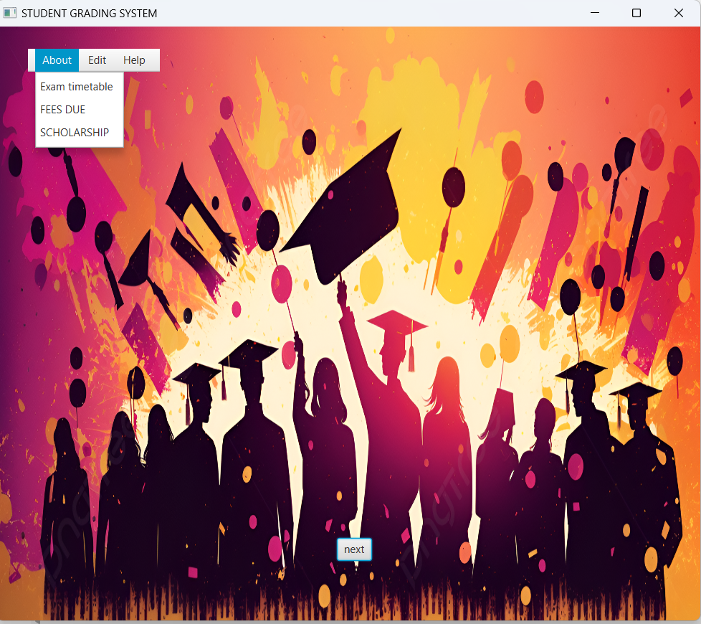**OUTPUT:**

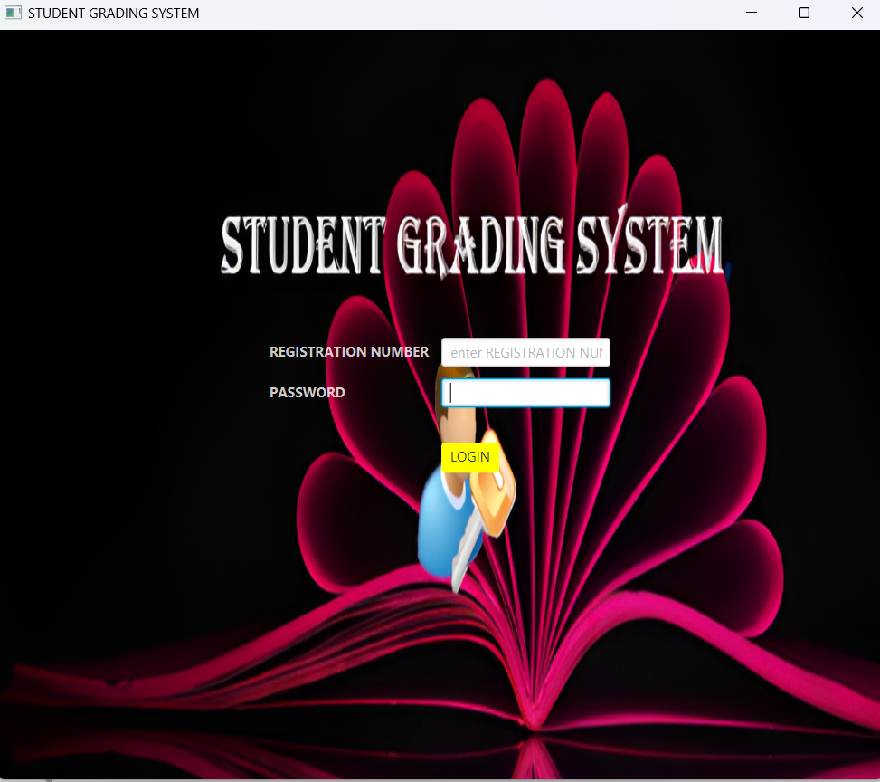

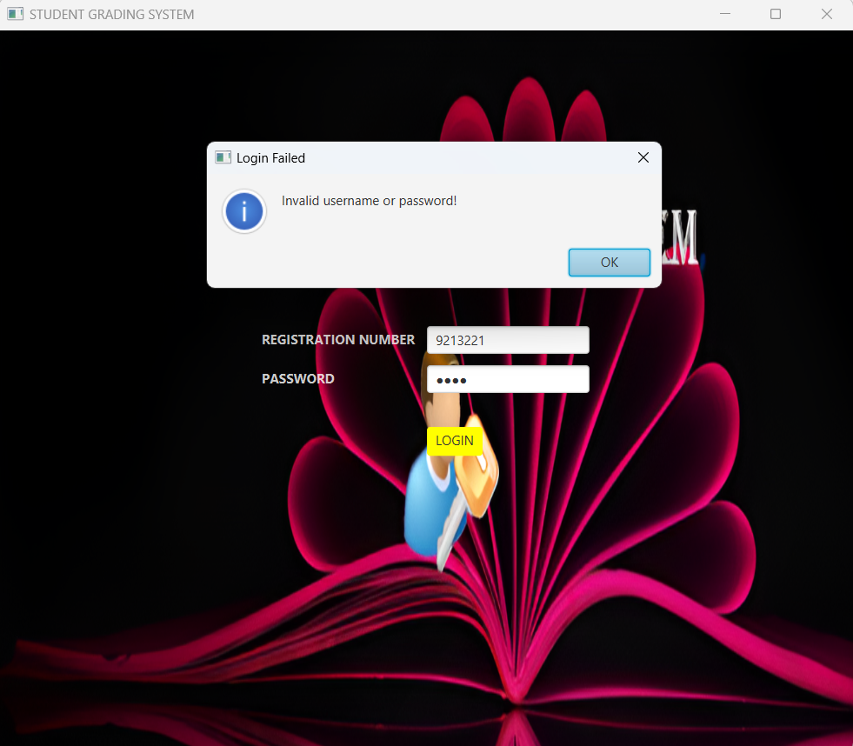

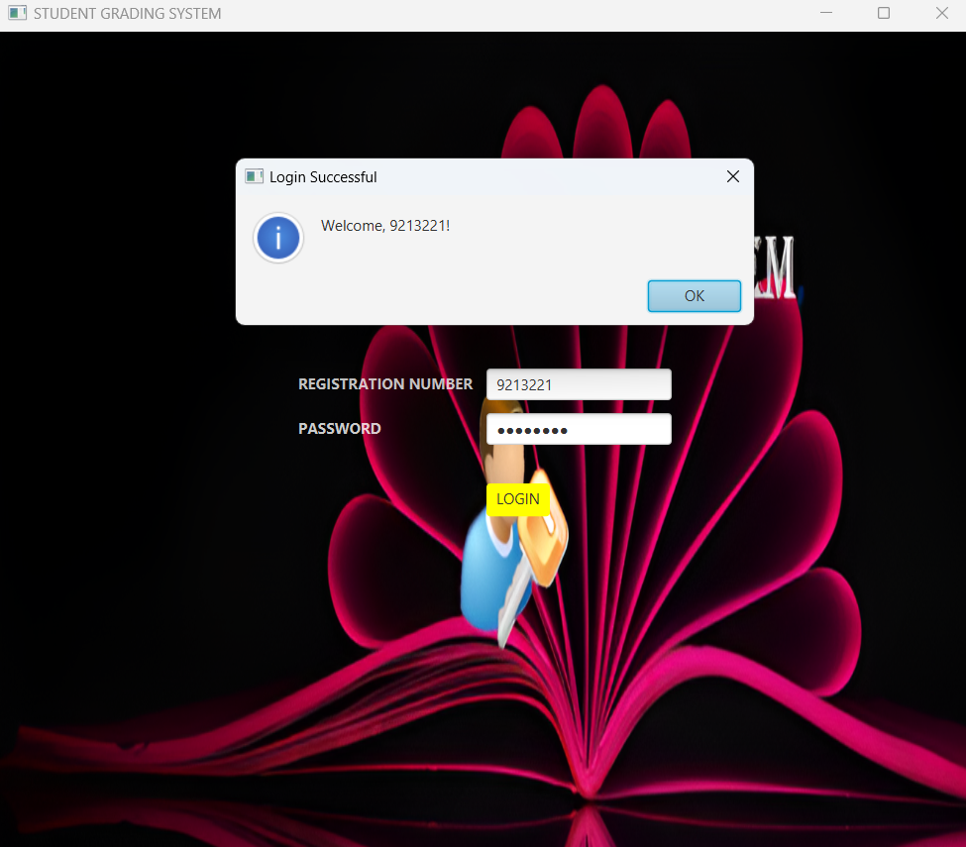

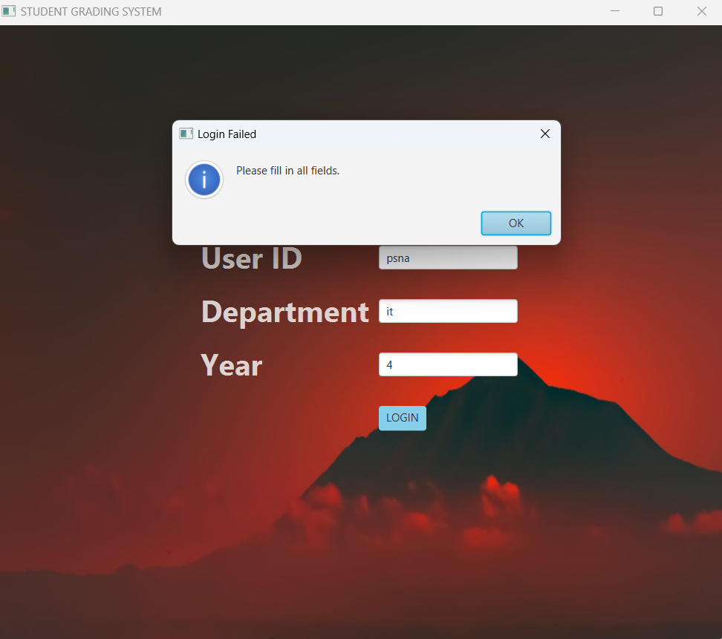

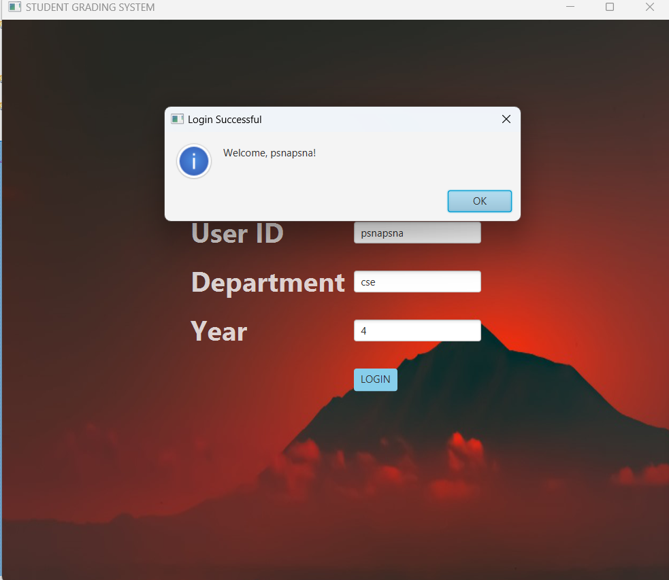

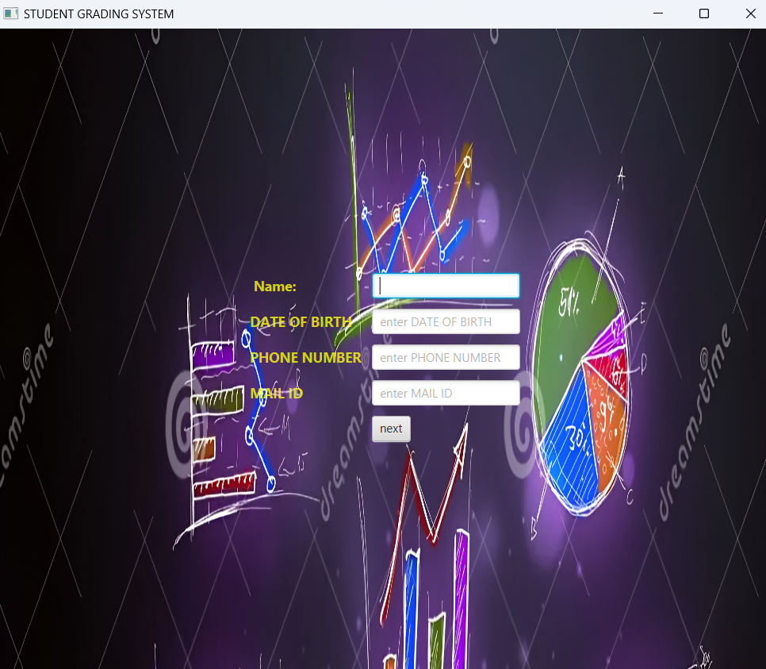

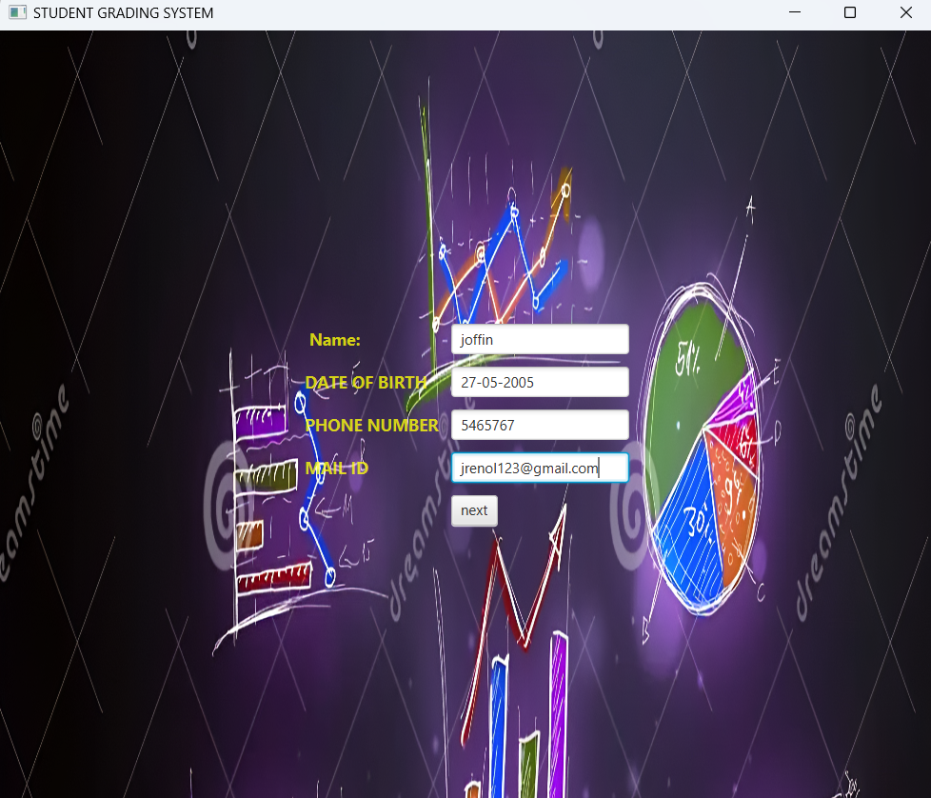

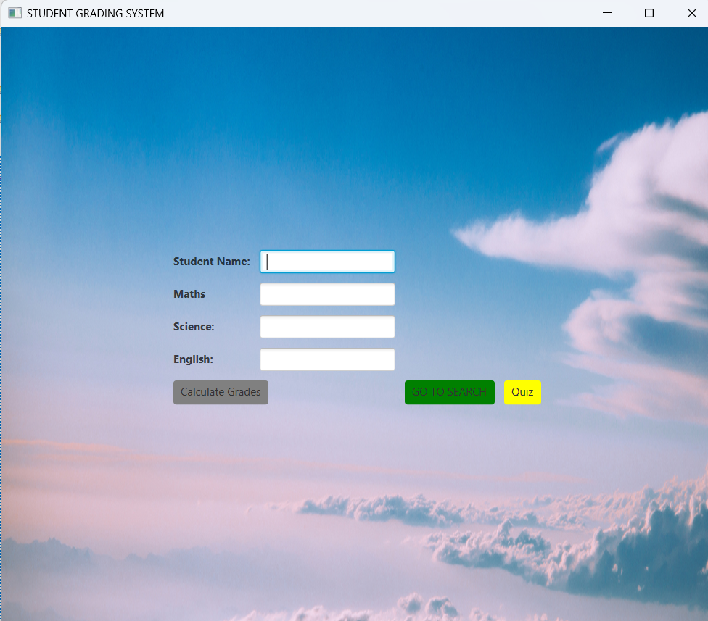

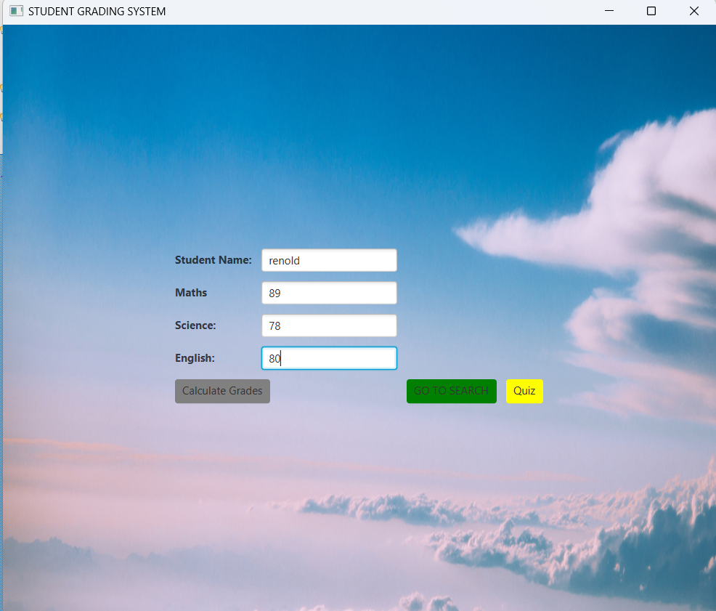

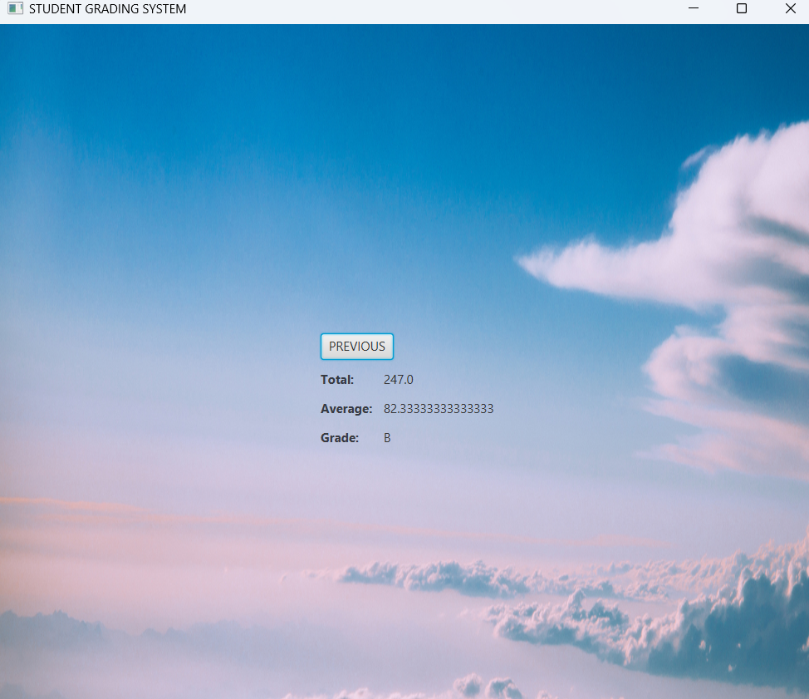

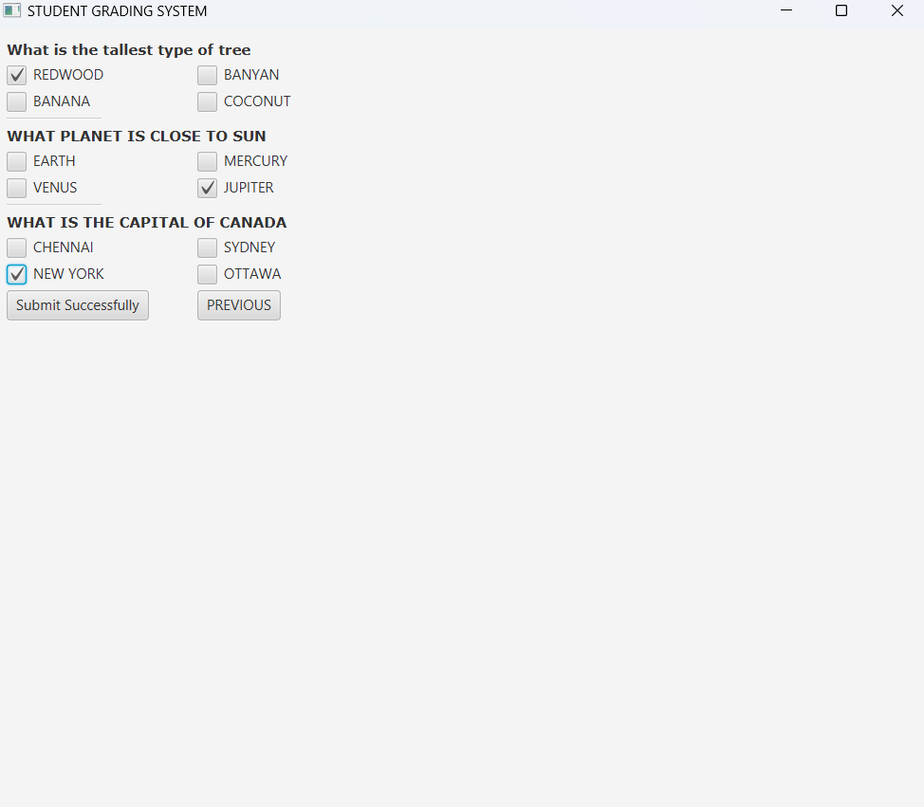

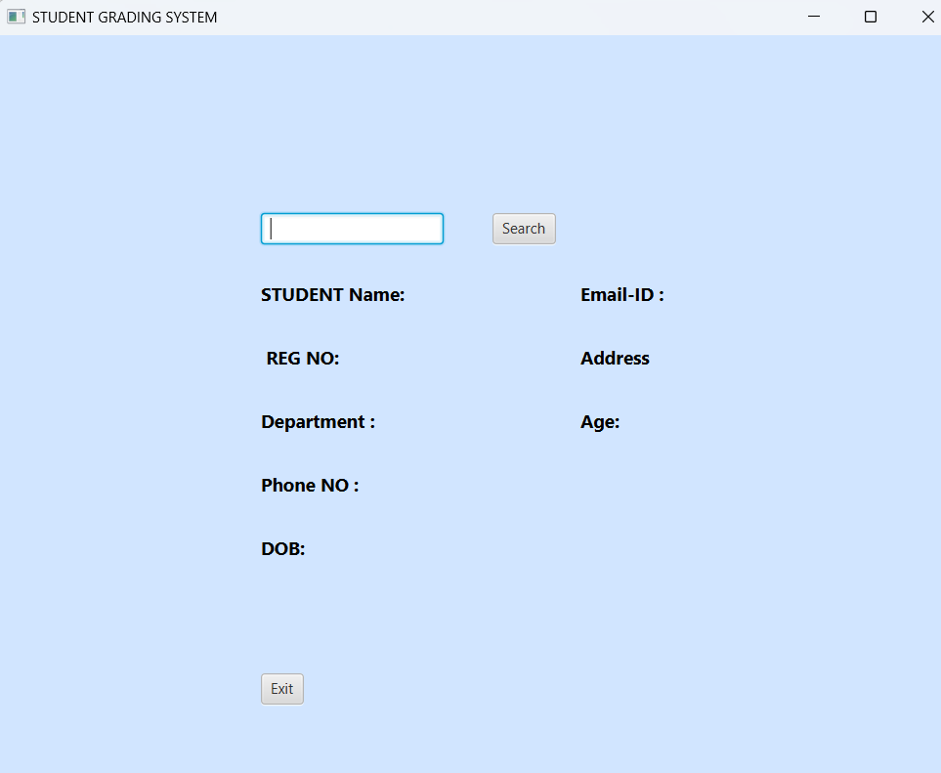

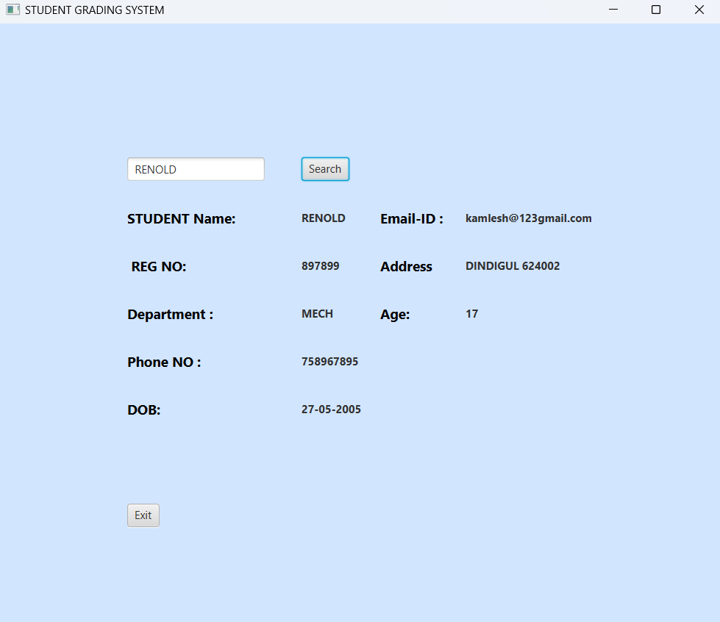

**DATABASE OUTPUT:**

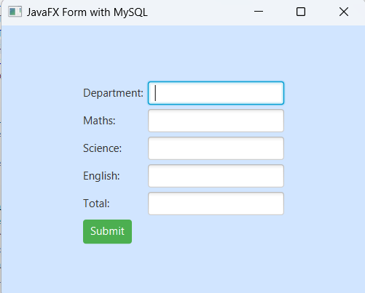

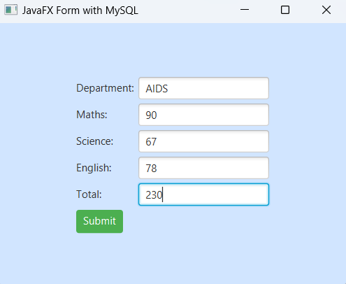

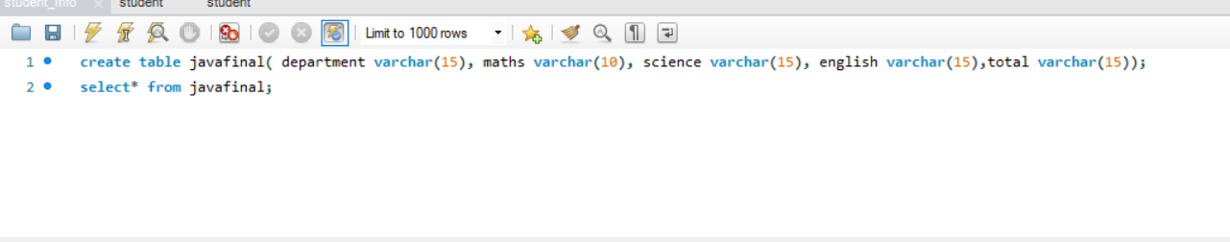

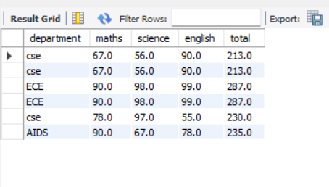

**RESULT:**

**Thus the above mini project for student grading system was verified and implemented successfully.**